Project Design Phase
Problem – Solution Fit Template

Date | 27 June 2025
Team ID | LTVIP2025TMID53093
Project Name | HouseHunt:Finding Your perferct Rental Home
Maximum Marks | 2 Marks

Problem–Solution Fit Template – HouseHunt Problem Identified
Many renters and property owners in semi-urban and urban areas struggle to connect reliably. Existing platforms are either too complex, unaffordable, or lack role-based access and verification features.
Proposed Solution
Our solution is HouseHunt, a web platform that connects property owners and renters with clear role-based access (user, owner, admin), property listing with image uploads, booking management, and owner approval features—all in one place.

Purpose Alignment
The purpose of HouseHunt is to provide a simple, secure, and transparent way for users to find and book properties and for owners to manage their listings, while admins ensure platform reliability and trust.

Template:
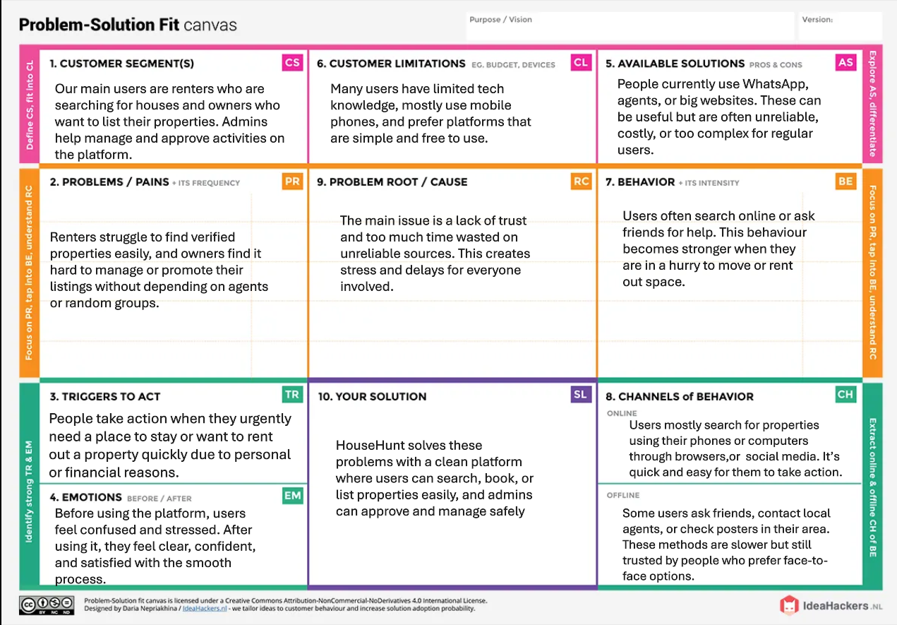
- WHO IS YOUR CUSTOMER?
- Renters (looking for property)
- Property Owners (listing their properties)
- Admin (approving & managing platform)
- EXPLORE LIMITATIONS TO BUY/USE YOUR PRODUCT OR SERVICE
  - Requires internet access
  - Desktop-optimized (mobile experience can be improved)
  - No direct payment gateway or live support yet
- HOW ARE YOU GOING TO BE DIFFERENT THAN COMPETITION?
- Role-based dashboards (User, Owner, Admin)
- Booking feature + owner approval logic
- Clean, responsive UI with search and filter

- FOCUS ON FREQUENT, COSTLY, OR URGENT PROBLEM TO SOLVE
HouseHunt solves the urgent problem of unverified listings, limited contact options, and disconnected rental systems.

- UNDERSTAND THE CAUSE OF THE PROBLEM
- Lack of integrated platforms where both renters and owners can interact securely
- Traditional rental systems are time-consuming and scattered
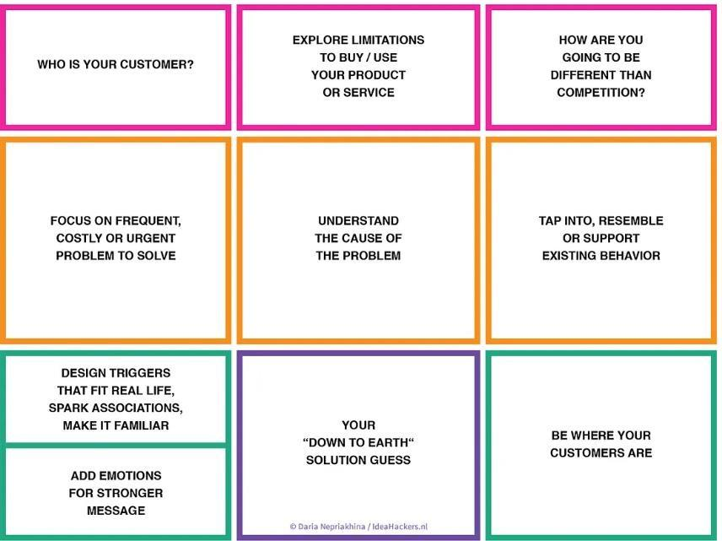
- TAP INTO, RESEMBLE, OR SUPPORT EXISTING BEHAVIOR
- People are already used to searching for rentals online.
- We follow the same pattern — search, view, book — to make it easy and familiar.

- DESIGN TRIGGERS THAT FIT REAL LIFE, SPARK ASSOCIATIONS, MAKE IT FAMILIAR
- Our platform looks and works like everyday apps people already use.
- We use simple buttons, clear labels, and smooth flow that feels comfortable.

- ADD EMOTIONS FOR STRONGER MESSAGE
- The platform name HouseHunt evokes the excitement and struggle of finding a home
- Clean UI design brings comfort, trust, and a sense of modern reliability

- YOUR "DOWN TO EARTH" SOLUTION GUESS
- We are not building a big complex platform.
- We just want to help users find and book properties easily, and let owners manage them simply.
- Our system is small, clean, and works well for basic rental needs.
- BE WHERE YOUR CUSTOMERS ARE

Our platform works on browsers — both mobile and desktop.
It helps renters and owners who already use phones or laptops to go online and search for homes

References

- IdeaHackers – Problem-Solution Fit Canvas
 https://www.ideahackers.network/problem-solution-fit-canvas/
- Medium by Epicantus – Problem-Solution Fit Canvas https://medium.com/@epicantus/problem-solution-fit-canvas-aa3dd59cb4fe

